ScreenShot Of the Final Dashboard

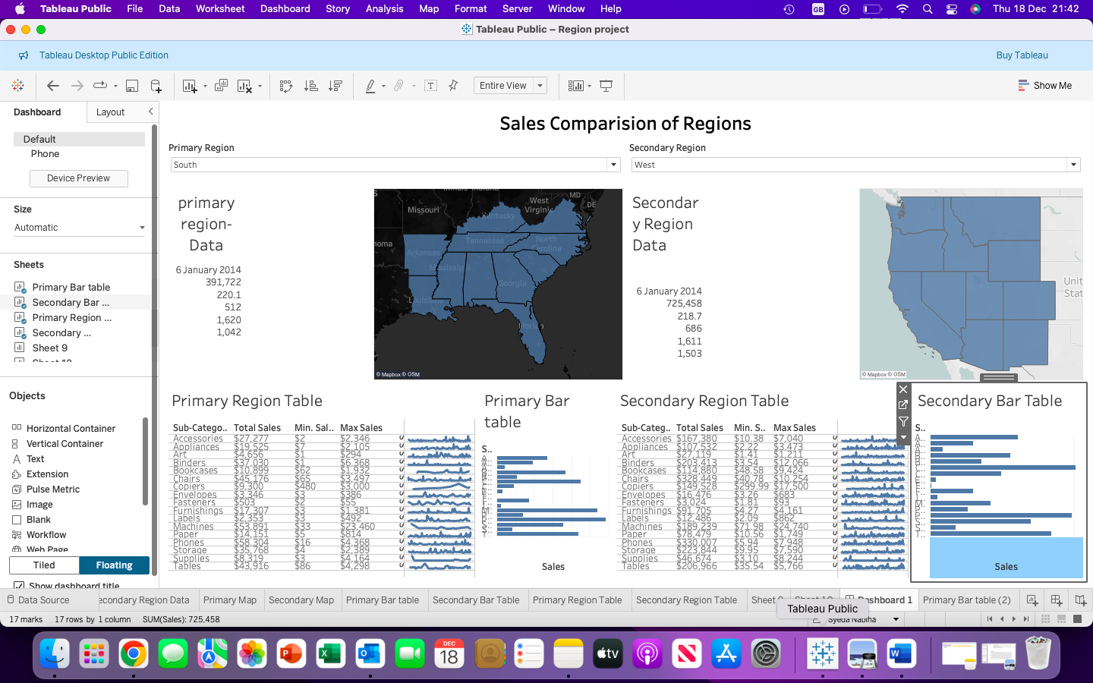
Fig:1 Screenshot Of Final Dashboard of the sales comparison of Regions

Sales Comparison of Regions – Dashboard Report
1. Introduction
This report explains the Sales Comparison of Regions dashboard created using Tableau Public.
The dashboard compares sales performance between two U.S. regions by analyzing geographic distribution,
product sub-categories, and key sales metrics.
2. Objective of the Dashboard
The dashboard aims to:
• Compare sales performance between two regions
• Identify top and low-performing product sub-categories
• Visualize geographic distribution of sales
• Support data-driven decision making
3. Dashboard Components
3.1 Region Filters
The dashboard includes two dropdown filters:
• Primary Region
• Secondary Region
All visualizations update dynamically based on selected regions.
3.2 Geographic Maps
Two maps display sales distribution across U.S. states for each region, helping identify regional sales concentration.
3.3 Regional Summary Metrics
Key performance indicators shown include:
• Total Sales
• Average Sales
• Number of Orders
• Quantity Sold
• Profit
3.4 Sub-Category Sales Tables
Tables show detailed sales information by product sub-category, including total, minimum, and maximum sales.
3.5 Bar Charts
Bar charts visually represent total sales by sub-category, enabling easy comparison across regions.
4. Key Insights
• Sales performance differs significantly between regions
• Certain product categories perform better in specific regions
• Sales are unevenly distributed geographically
5. Conclusion
The Sales Comparison of Regions dashboard provides a comprehensive and interactive way to analyze regional sales performance. By combining maps, tables, and bar charts, the dashboard enables users to identify trends, compare regions effectively, and understand product-level performance.
This dashboard can support strategic business decisions such as regional marketing focus,
inventory planning, and performance optimization.

Tableau region project link:

https://public.tableau.com/app/profile/syeda.nabiha/viz/Regionproject_17660939542830/Dashboard1?publish=yes

